**Servlet assignment:**

Q1) Write a servlet that lets a user vote for his favorite food from a combo box or radio Buttons (the user must be able to make multiple food selections per request). Store the favorite foods and the number of votes for each food. Please note that a user from one IP address can vote only once. Display all foods and their number of votes in alphabetical order back to the user. Use an appropriate Collection class or Map class to store the data.(or database can also be used to store data).

Q2)

Use session tracking to make a servlet that says ” Welcome Bhopal ” to first-time visitors (within a browsing session) and ” Welcome Back ” to return visitors. Do this job using Session Tracking and Cookies. Also compare these 2 approaches with respect to simplicity.

Also displays the number of times it has been accessed

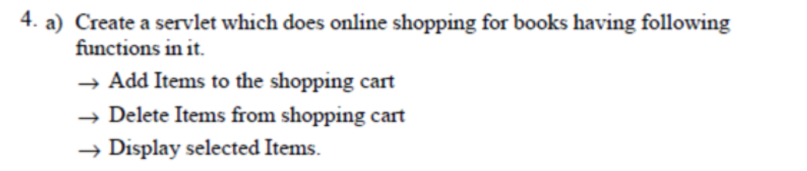

Add a AuthenticationFilter which should check the user has logged in before he is trying to adda book, delete a book or display books. Anyone can make request to login page but for other pages, he should be a valid user and add a logout functionality too